**Project Third Increment Report**

**Features developed for Increment3:**

1. Profile Page
2. History Page
3. Node modules for Forgot password, Successful Registration and Sending a mail to admin
4. Filtering Places based on user budget
5. Finding the shortest path of the places filtered on budget
6. Creation of Day to Day Plan

**Existing Services/REST API:**

<https://console.developers.google.com/google/maps-apis/>

**Detail Design of Features:**

1. **Wireframes& mockup:**

**HomePage**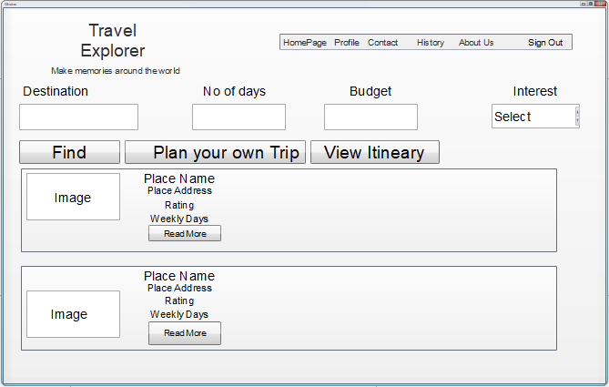

**Contact Page**

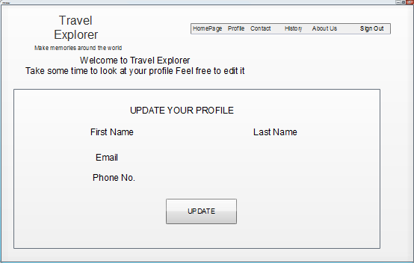

**Direction Page**

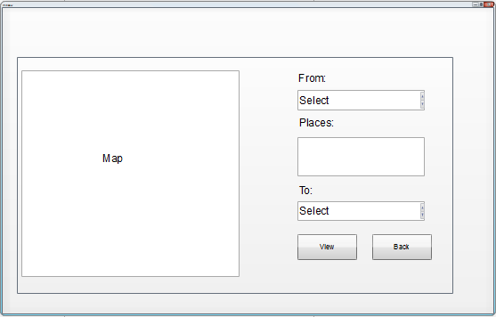

**History Page**

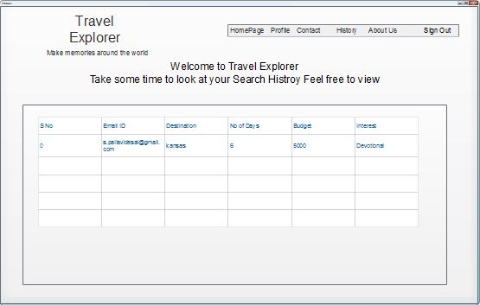

**Itineary Page**

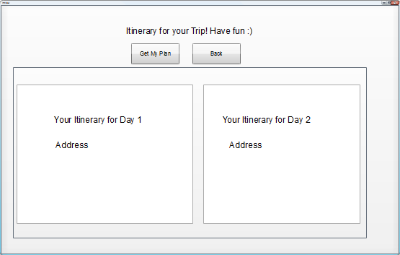

**About Us Page**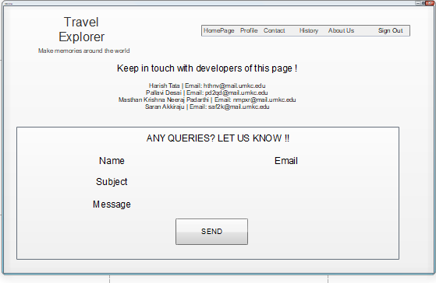

**Basic Functionality:**

Users will be able to see their profile details and also able to update their profile. Users will be able to see the history of searches by them.

Users will be able to receive email upon Successful Registration, on clicking forgot password link and also send email to admin of the application in case of any queries.

Filtering of the places can be done based on the budget given by the user. Application will fetch the details of the places which are rated high by the users in Google reviews and if they fall into the budget constraint given by the user.

There is an option for a user to create a custom plan, where user can select any place as source and destination, can look for a route in the maps and can also select multiple places and create their own.

Application creates a day to day plan considering the user budget, interest, number of days he/she planned to take the trip and also the places that are near to each other.

**2. 1 Architecture diagram:**

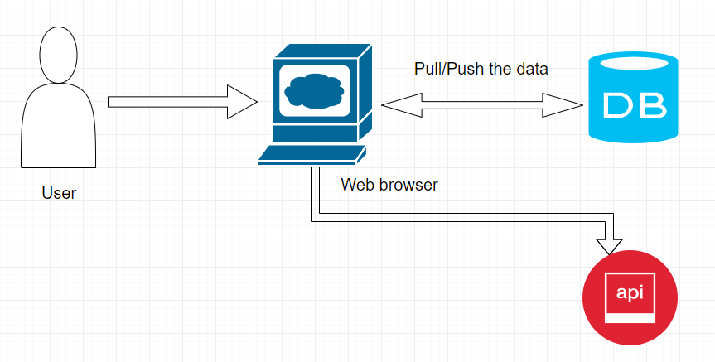

**2.2 Sequence Diagram:**

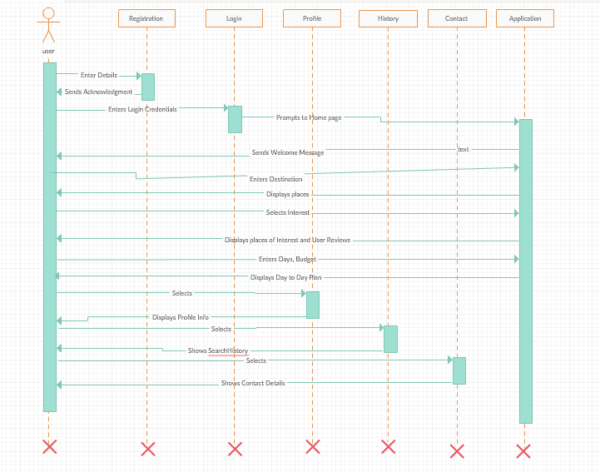

**2.3 Class Diagram:**

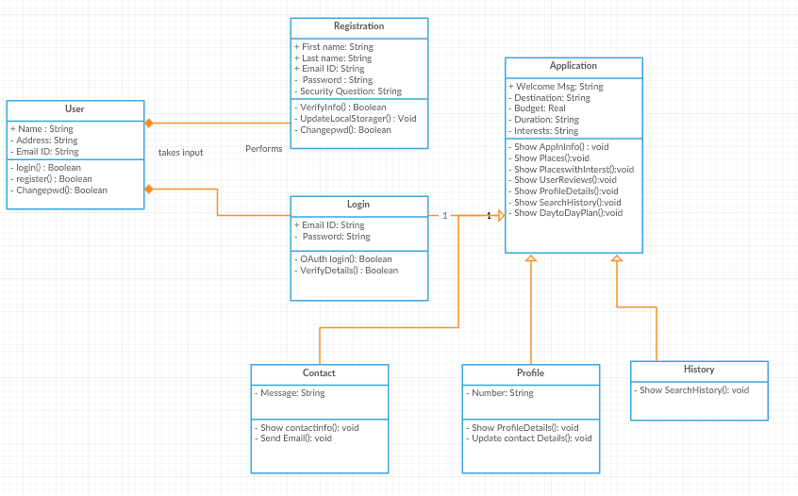

**3. User Stories**

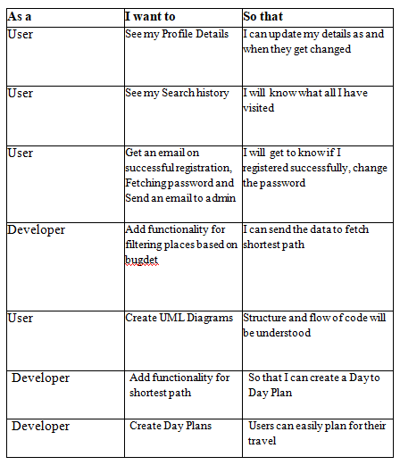

## 4. Testing

**Travel Explorer – Web Application:**

**Profile Page**

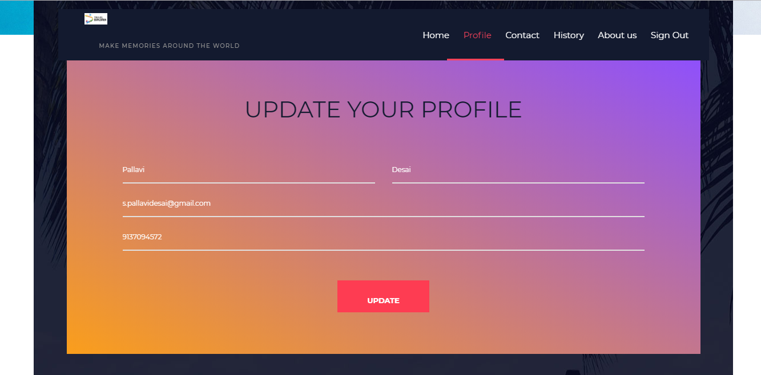

You can update the information like phone number last name etc.

**History Page** 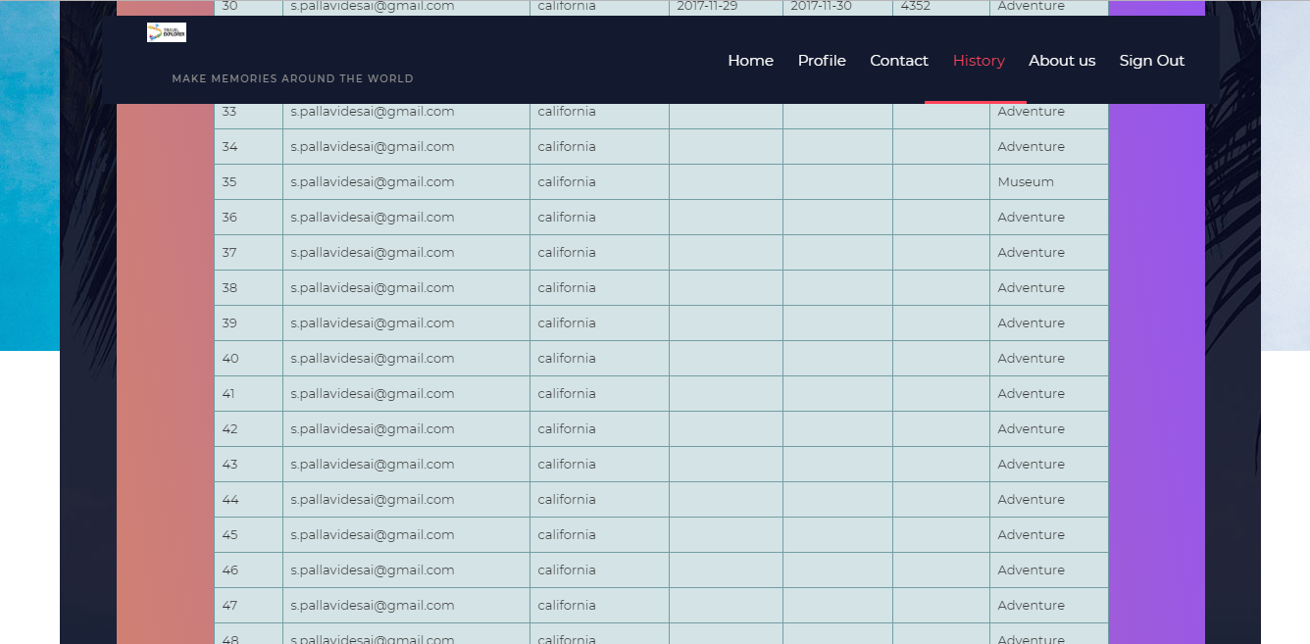

This page shows all the history which is searched by the user before when he /she logged into the the account.

**Home Page**



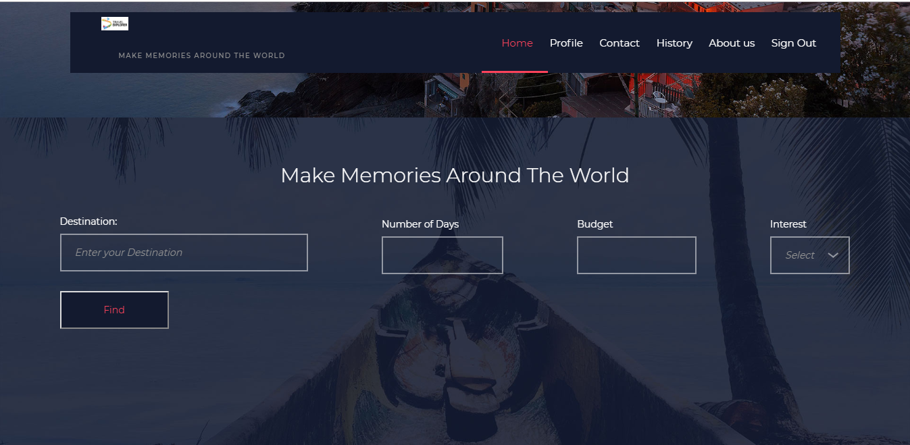

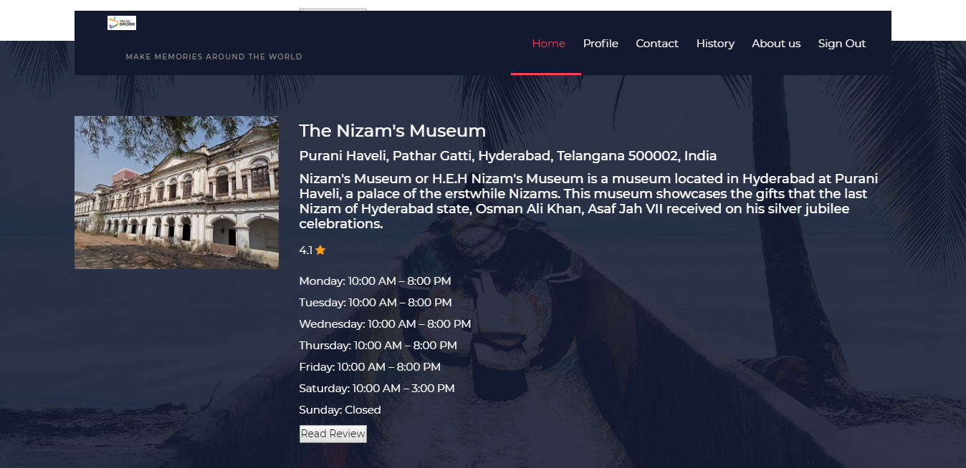

You can see the searched places with the given interest and place with the given budget by the user.

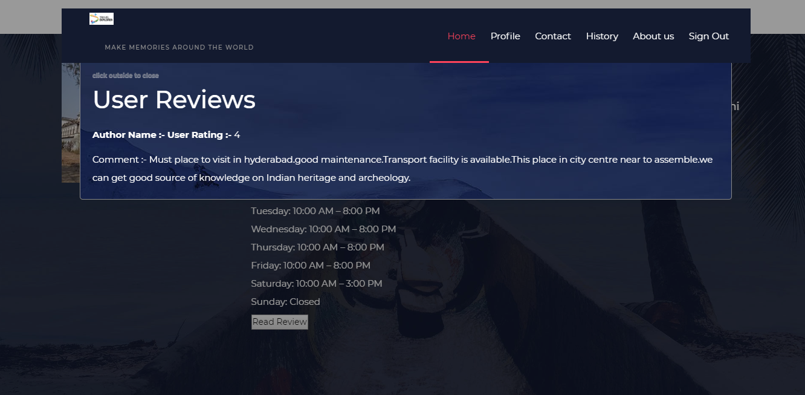

The user rating you can see in a popup ,So as to see that you can click on read more which displays the user rating and review of that particular place.

**User Customized Plan Page**

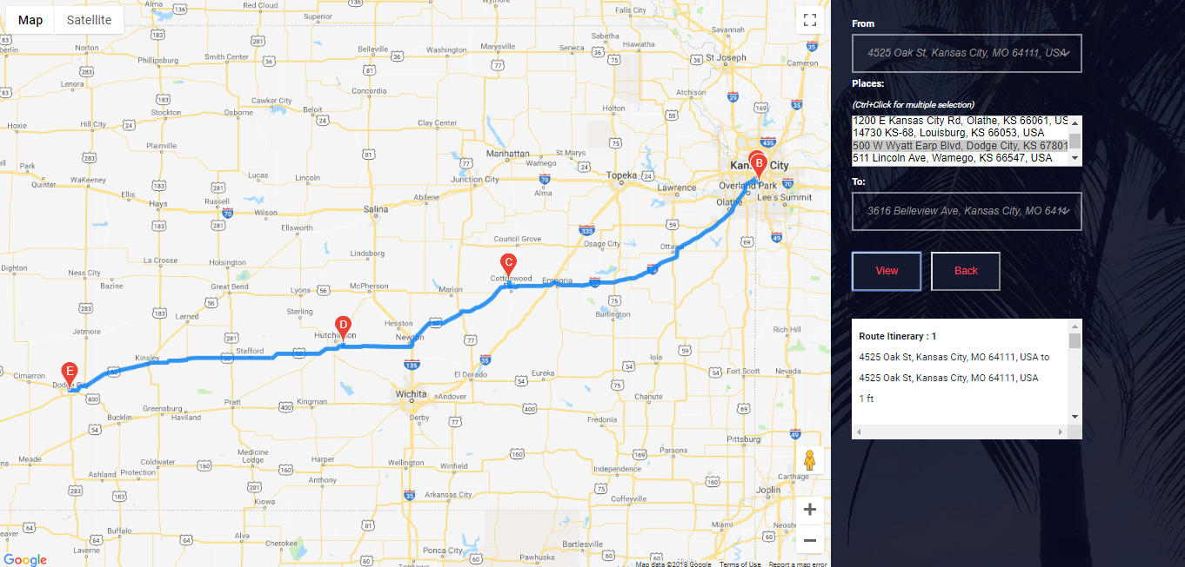

In this page the user can make his own plan with the help of place address present in the box .The user has to select from ,to and the waypoints (waypoints is optional) and make his own day or full trip plan

**Day to Day Plan Page**

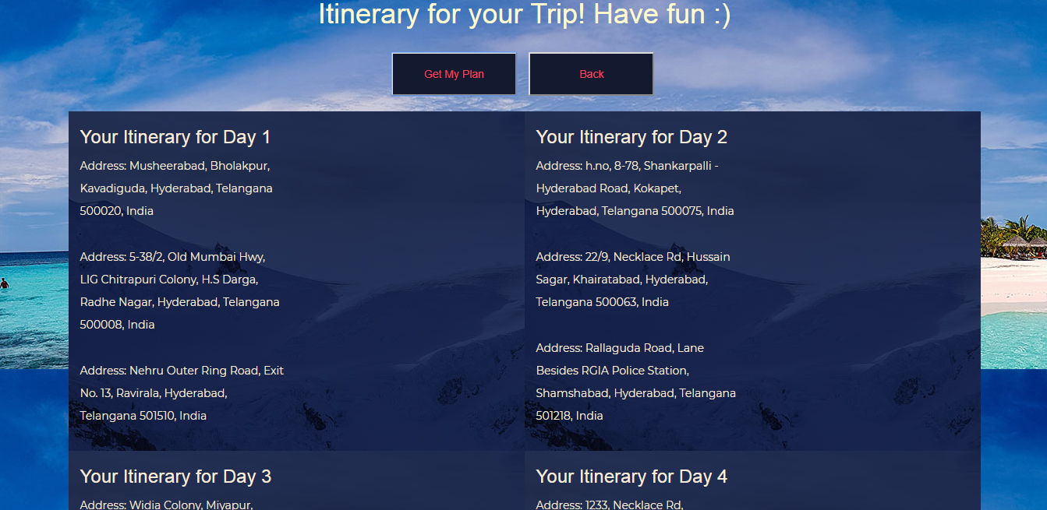

Here is the itinerary given to user according to the budget constraint and the shortest path taken into the consideration

**Please find Github Wiki below:**

https://github.com/shannu1221/CS5551_Team8_Project/wiki/Project-Increment-1

**Project Management**

**Board Issues:**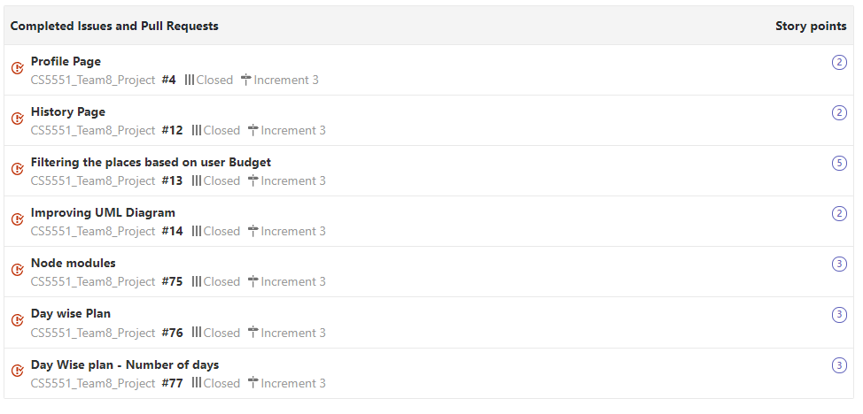

**ZenHub report:**

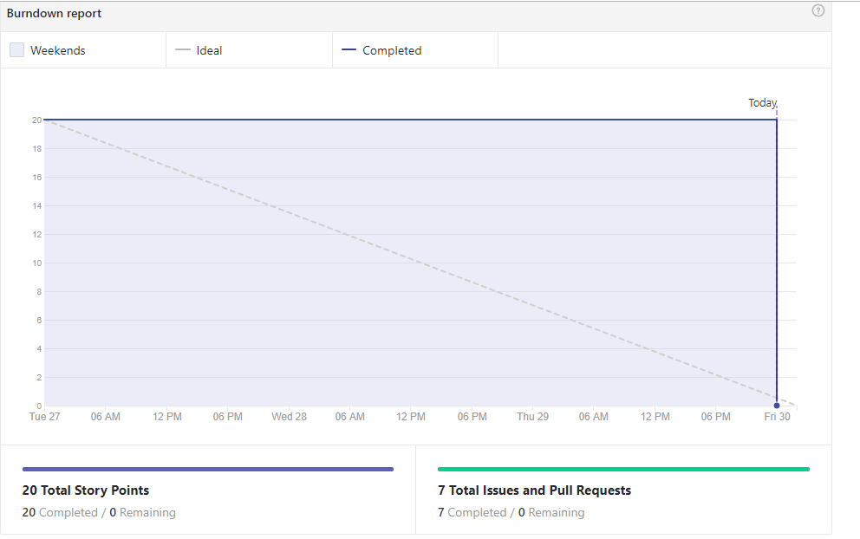

**Contribution chart:**

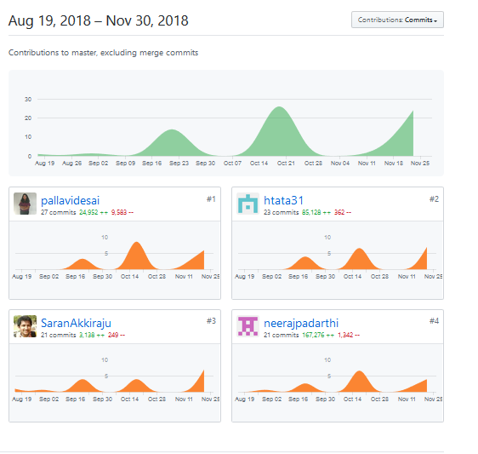

**References:**